Portfolio

Elias Maynor

**Giada Imaging Project**

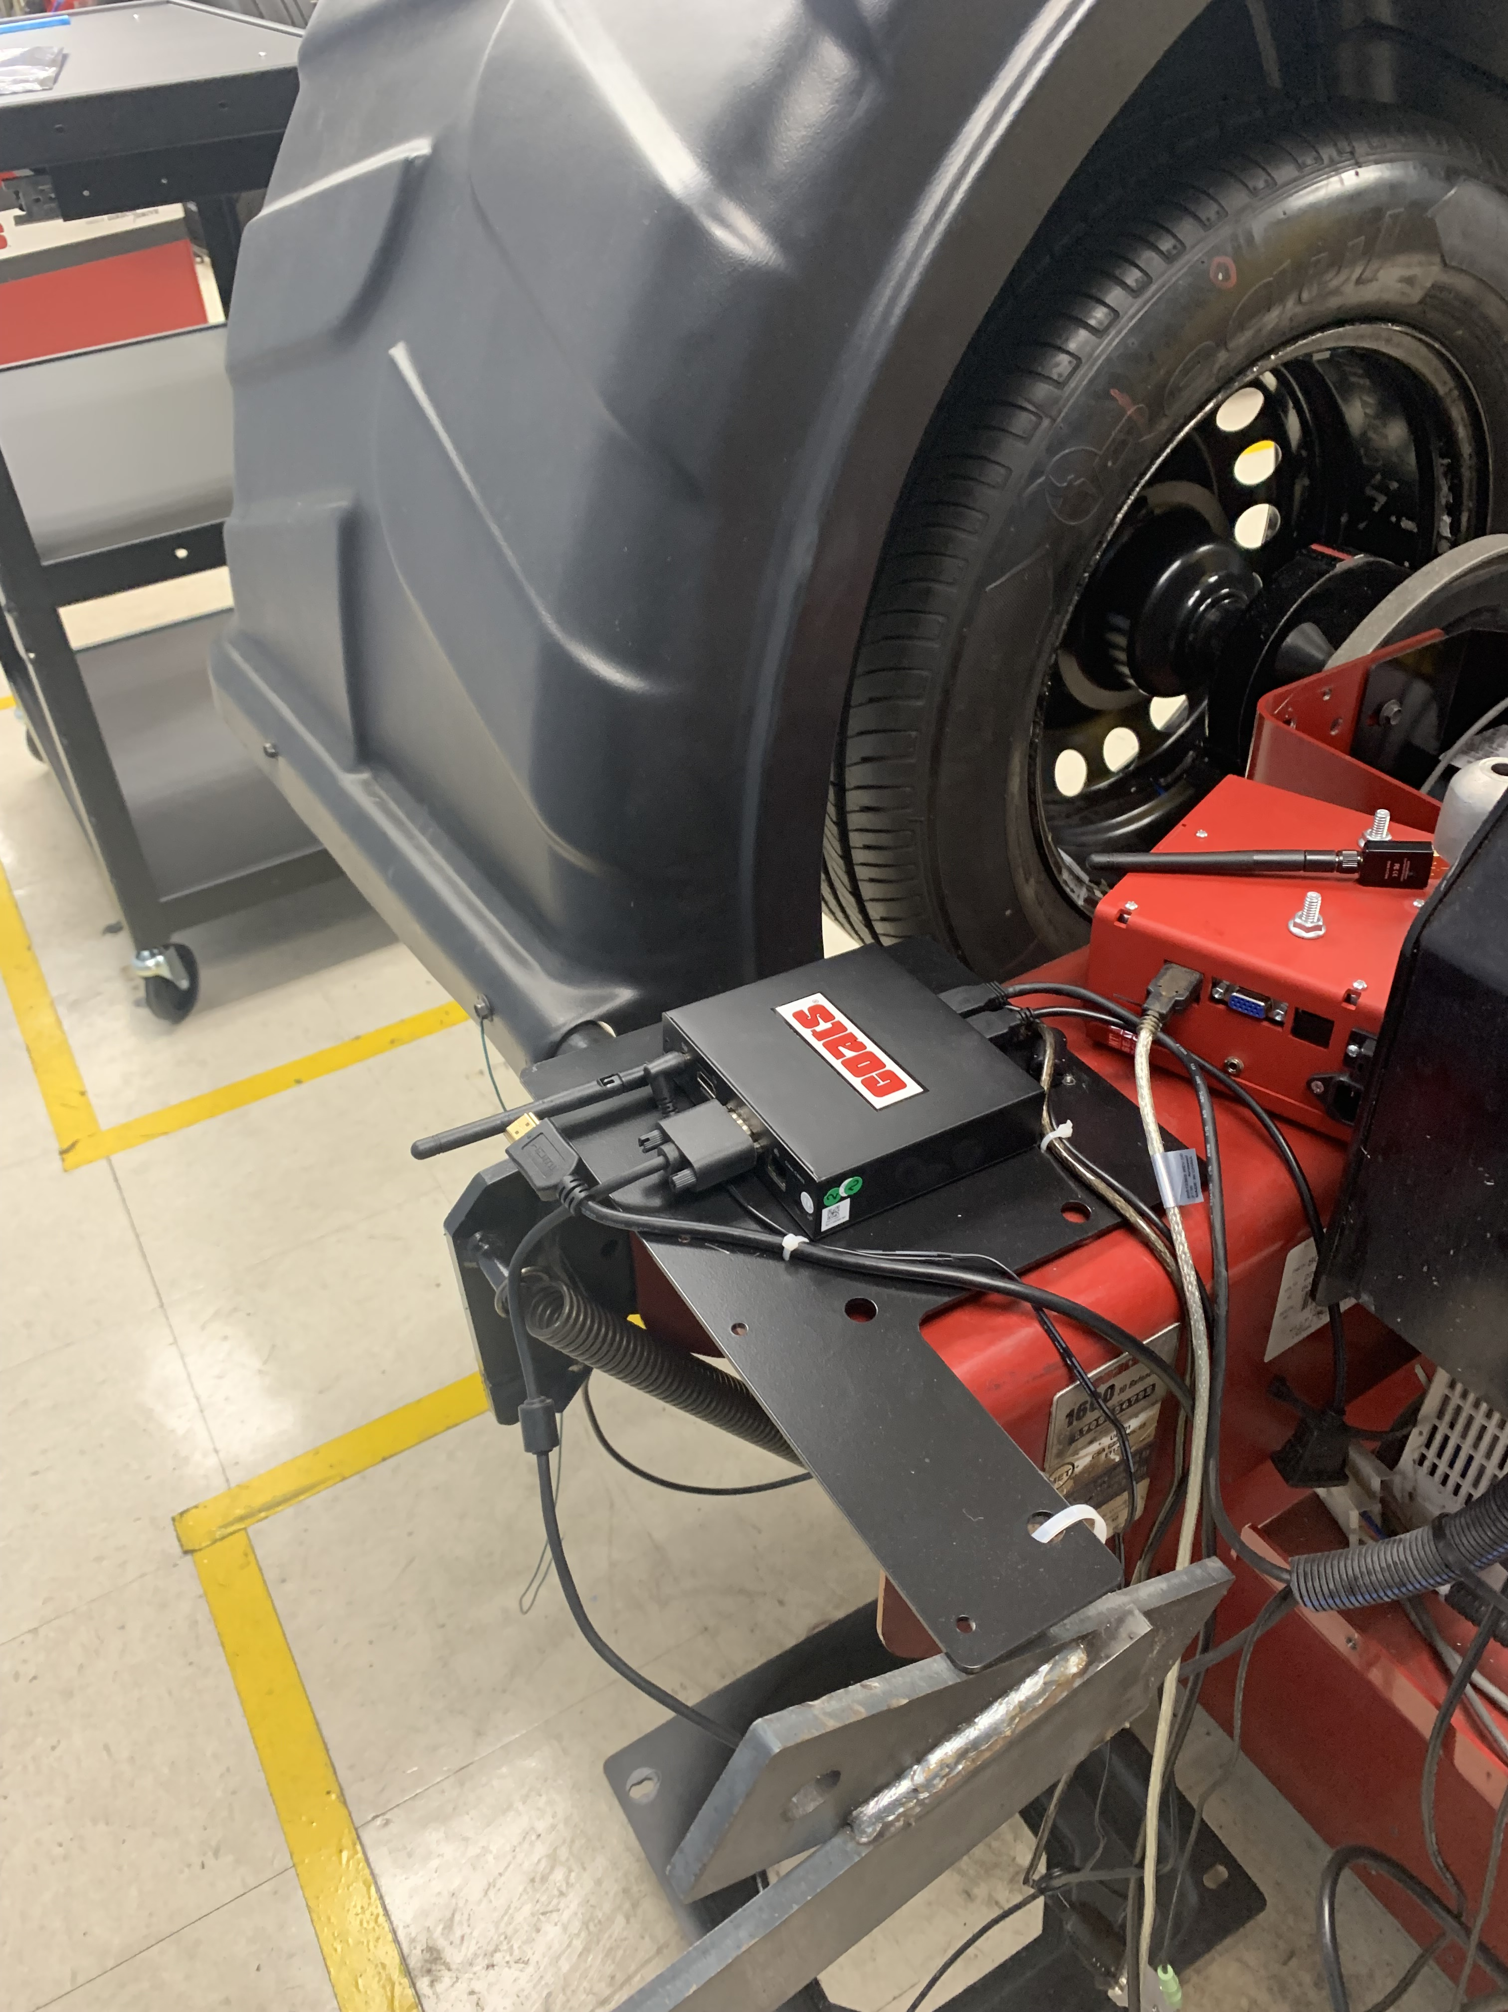 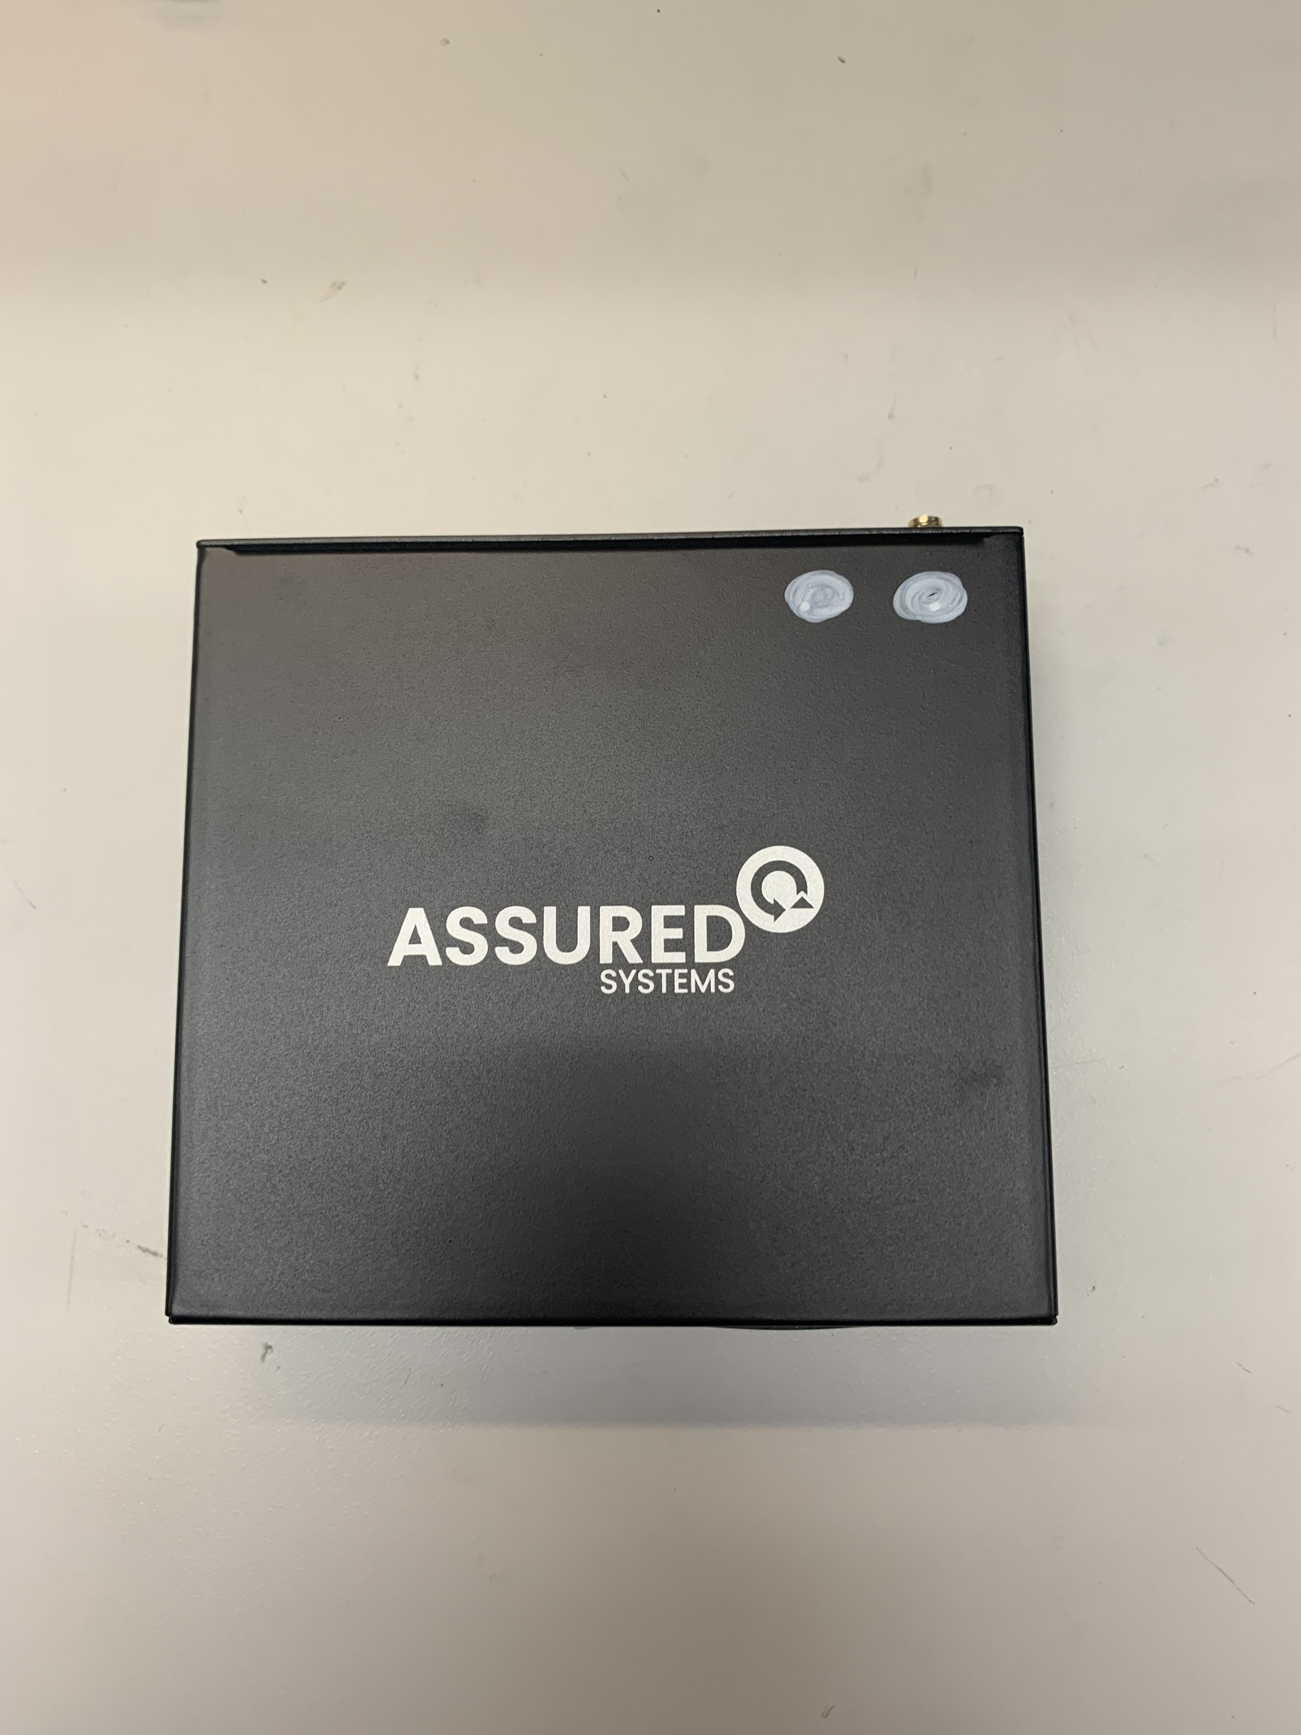

Problem

* The current image on the Giada PC was issue and freeze prone as it was optimized incorrectly leading to freezes and other issues when using the user interface.

Process

* Due to the current image being inadequate a new image was needed. Once the new image was created, we had to load the image onto the Giada PC using clonezilla software through a process called reimaging.

Result

* The PC could be reimaged through a reimaging process which would then allow the PCs to be used on the balancer with significantly less issues. This fix saved the company from having to send the PCs back to be reimaged at a cost of ~$25,000.

**Emerson Drive Update Project**

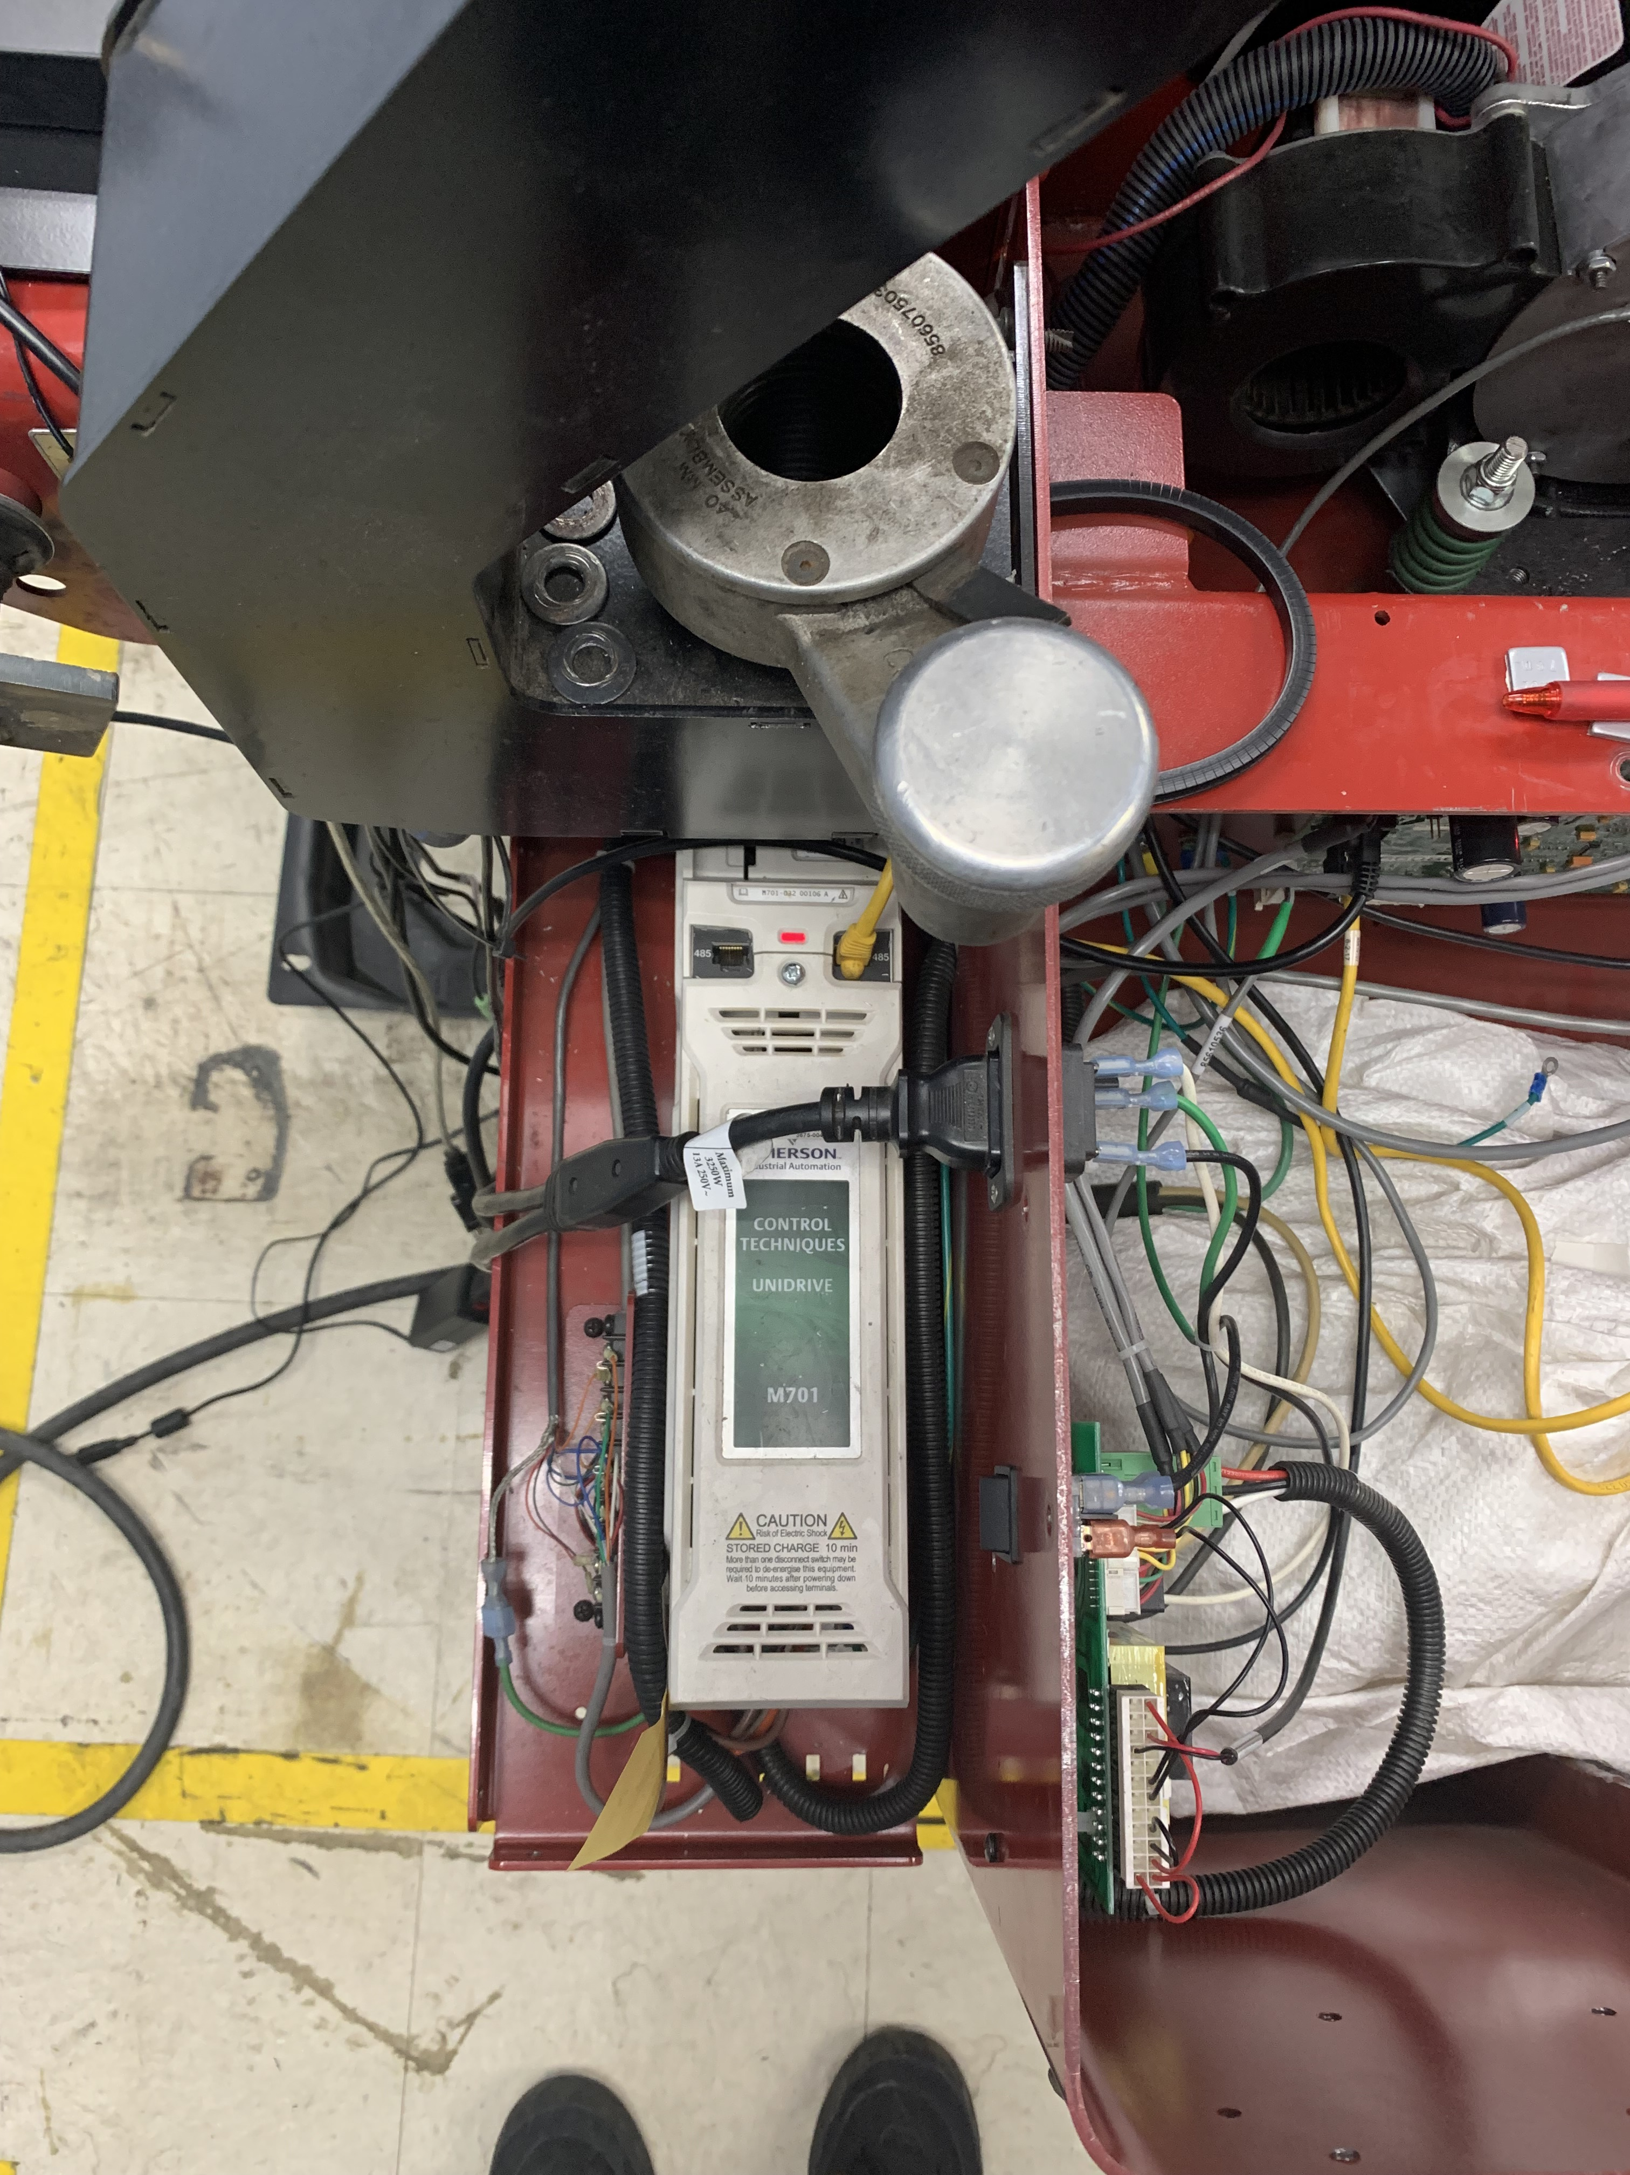 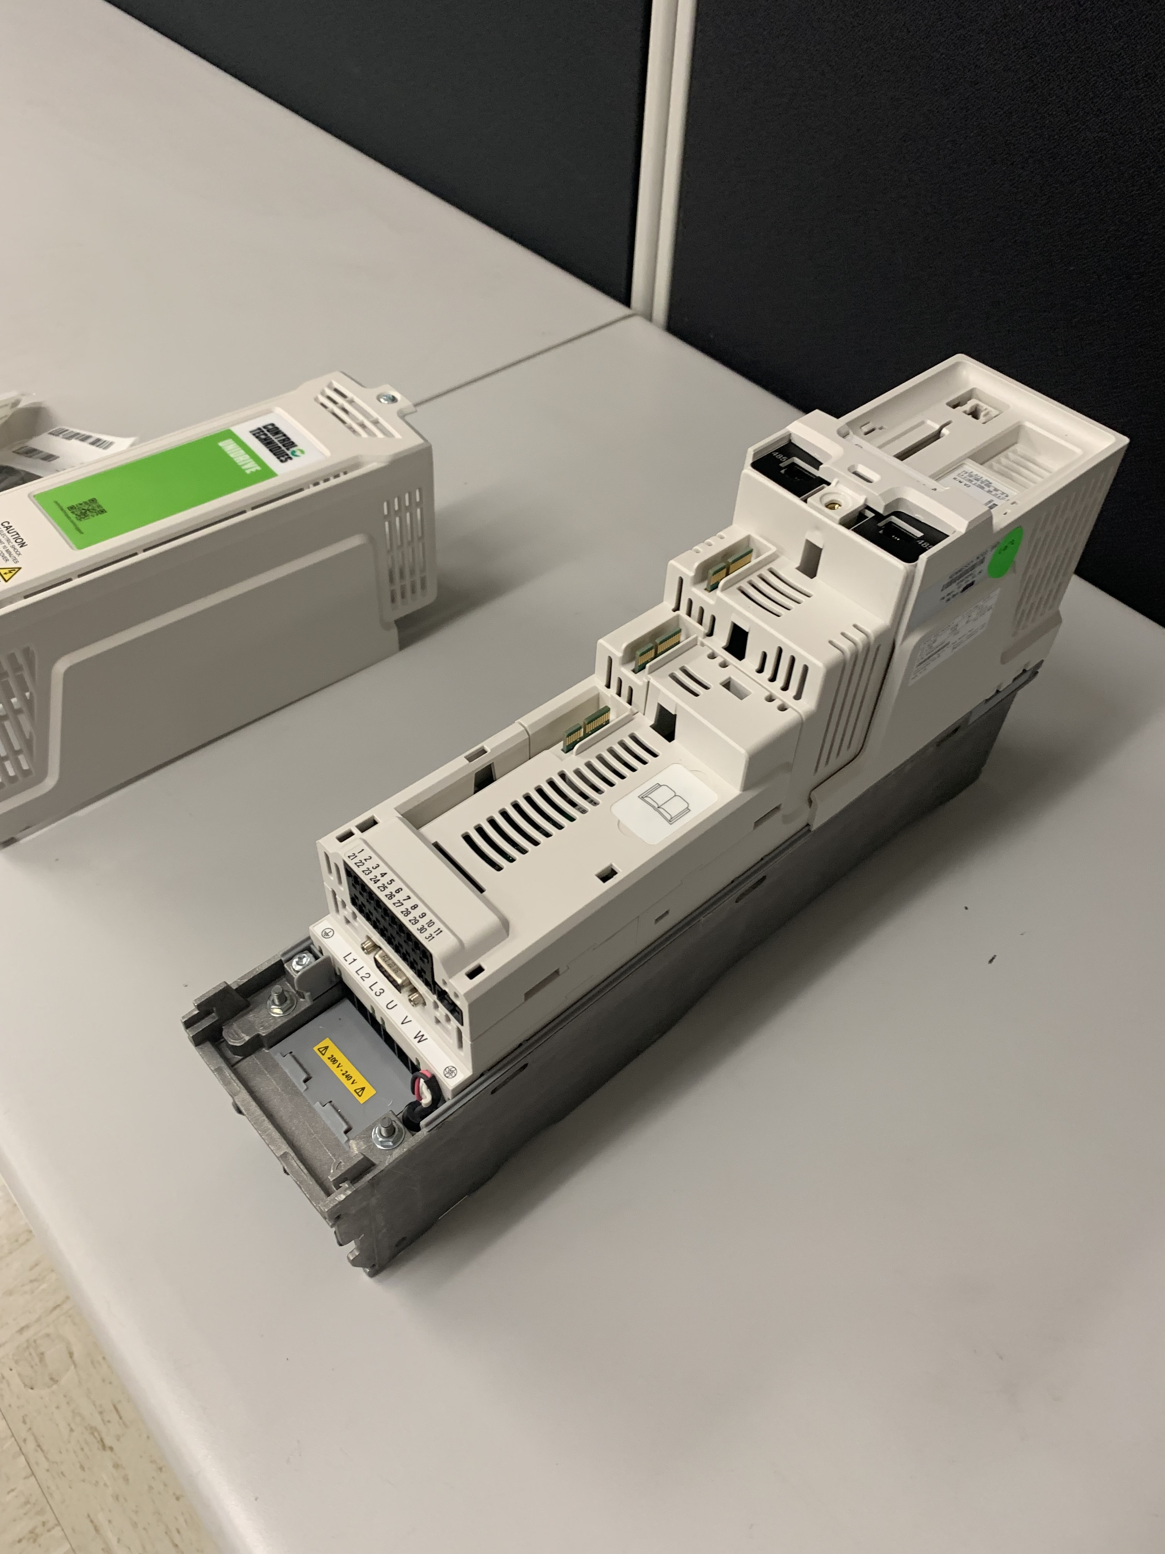

Problem

* The Coats Tire Balancer uses a mechanism called an encoder to keep track of the movements of the wheel. A cheaper alternative is available with relatively few differences to the expensive model. However, the change in encoder also requires an update in the Drive software.

Process

* The updating process for the drives starts with the drives being placed in a metal rig. After the drive is securely in the rig then you can insert the SD card holder, Serial adapter, as well as power. After the drive is powered on updating just requires typing a few numbers and resetting the drive.

Result

* This process was very time efficient which allowed for close to 300 drives to be updated in less than a week. This update resulted in no longer needing to buy the more expensive encoder.

**Sonar Housing Assembly**

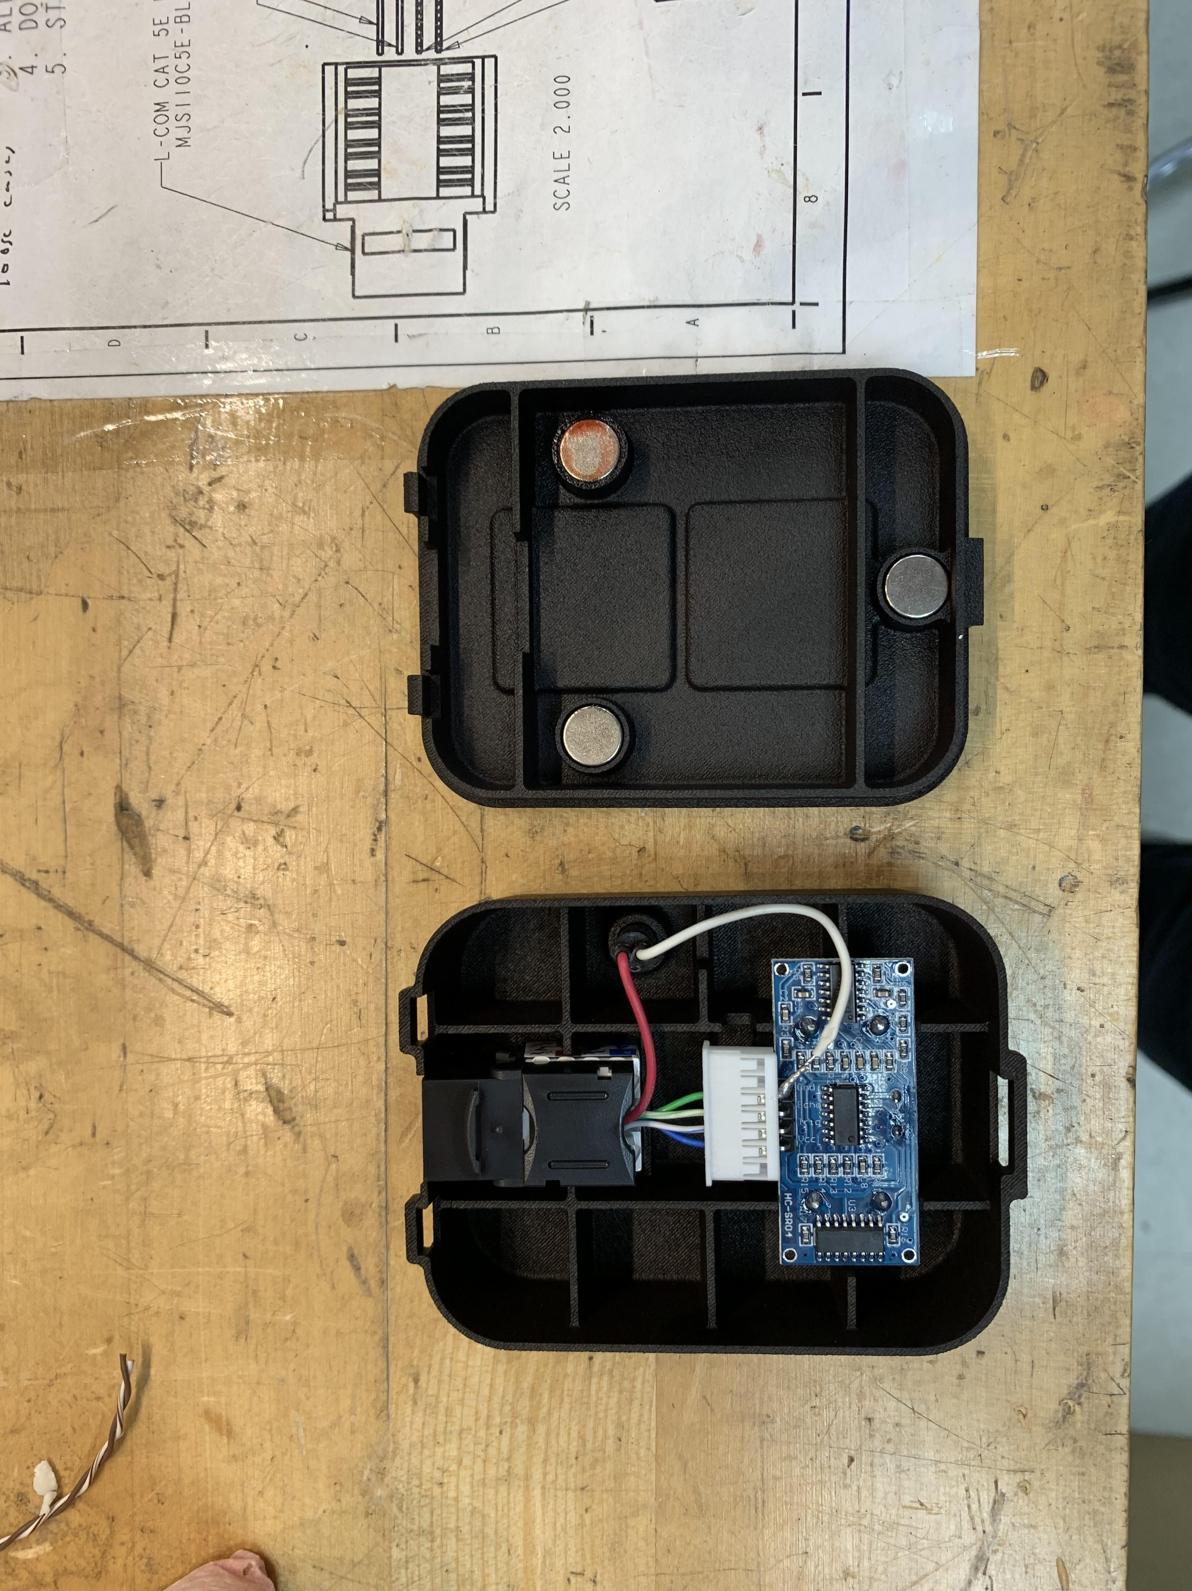

Problem

* The Coats Sonar Sensor System is a part of the Coats Bayley Service Intelligence system. This system allows for the shop to sense whether cars are being worked on during a specific moment.

Process

* The manufacturing process of the Sonar requires for the housing to be 3D printed offsite and assembled in house. The assembly process required for an ultrasonic sensor wired to a keystone jack to supply power to the system. Once this has taken place a light is soldered to the board and the lid is attached

Result

* By doing most of the manufacturing in house and ensuring that the sonar worked through a testing system we were able to guarantee the customer a quality product while saving money on manufacturing costs.

**Lunabotics**

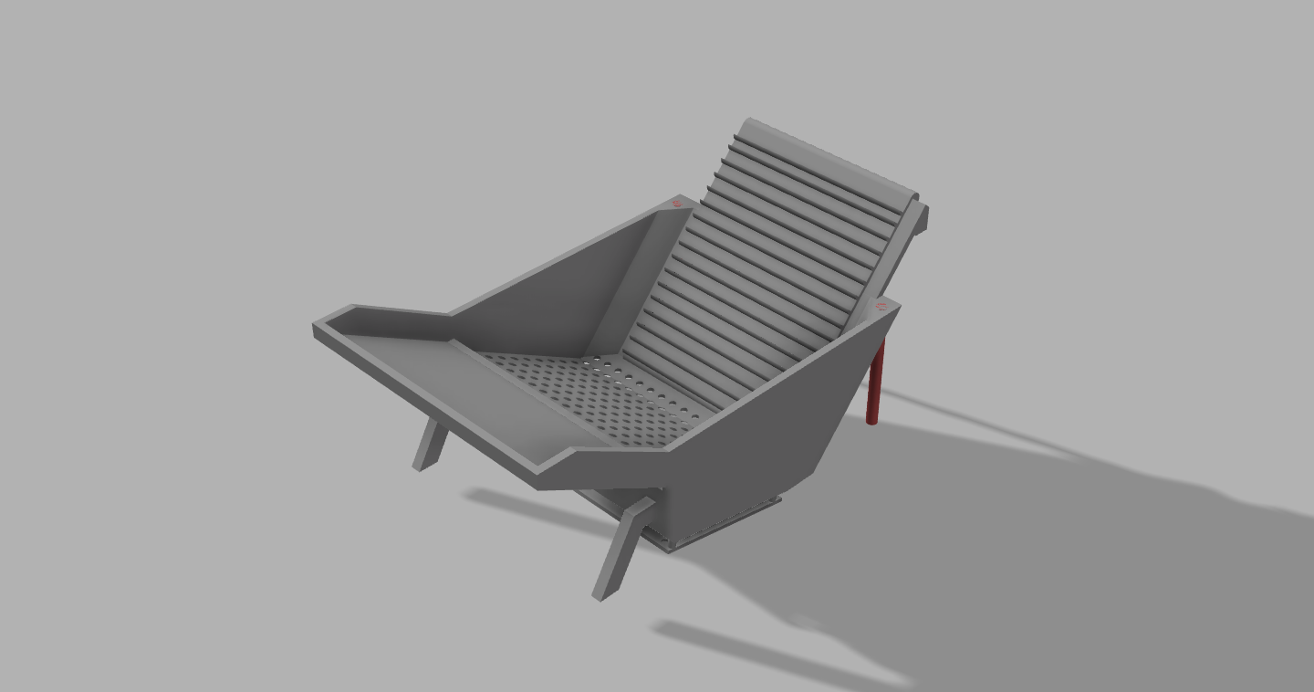

3D CAD Modeling

* As a member of the University of Tennessee Lunabotics Team I have taken part in the design of multiple parts of the overall robot architecture. As seen to the left this is a storage mechanism for the robot which would be used to store gravel. Incorporated in the system is a sifting mechanism to expel unwanted material.